https://qashqadaryo.mehnat.uz/storage/openItems/1665119612.pdf | 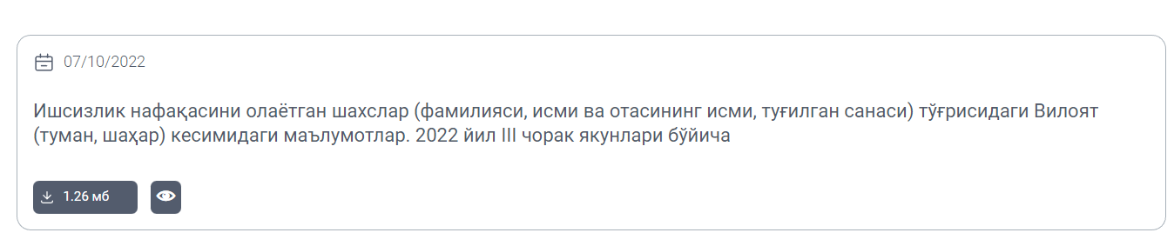 | 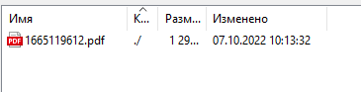
https://surxondaryo.mehnat.uz/uz/document/view?path=%2Fstorage%2FopenItems%2F1656995990.xls | 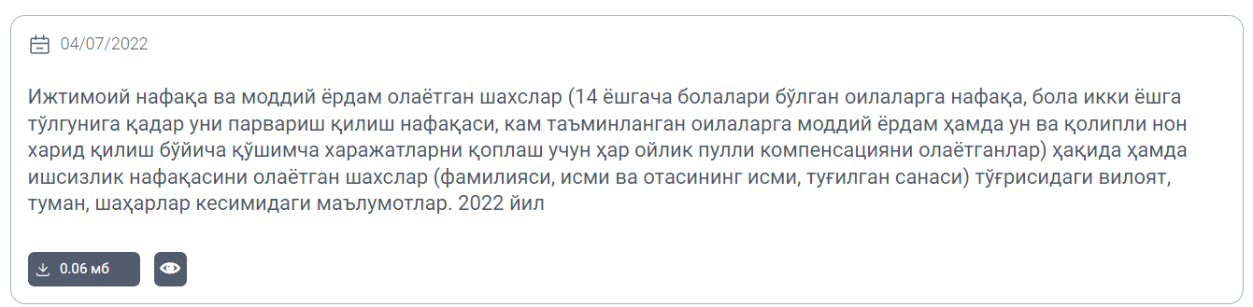 | 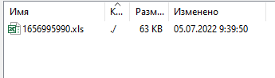
https://andijon.mehnat.uz/uz/document/view?path=%2Fstorage%2FopenItems% | 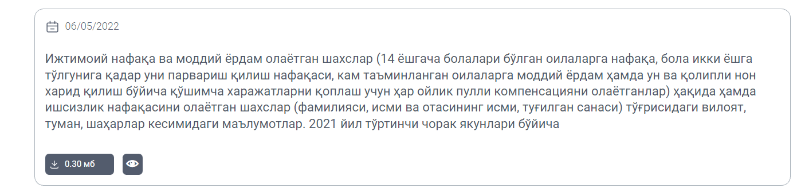 | 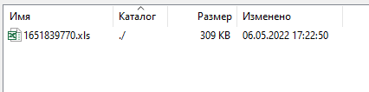
https://namangan.mehnat.uz/storage/openItems/1665379908.pdf | 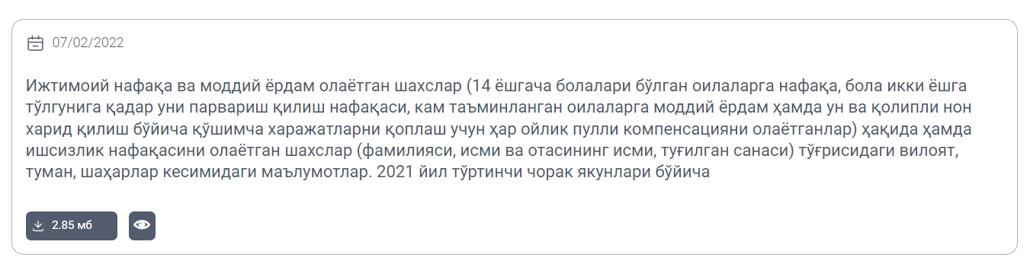 | 